YEAR 12 CHEMISTRY – 3BCHE

PRACTICAL TEST – PART 2

Volumetric Analysis – Written Section

Recommended time: 30 minutes
Total marks

/ 26
Name: _____________________________________________________

Teacher: _____________________________________________________

Write the correct name or formula for each of the following descriptions

1 | The procedure of adding one solution to another until the reaction between them is complete. | titration
2 | A small volume of solution taken from a larger volume. | aliquot
3 | A piece of equipment that can be used to prepare and/or store an accurately known volume of solution. | Volumetric flask
4 | A solution whose concentration is accurately known. | standard
5 | A solution that can be obtained using a substance with high purity having a known formula and high molecular mass. | Primary standard
6 | A piece of equipment used to accurately deliver a set volume of solution. | pipette
7 | A calibrated, tubular piece of equipment used to accurately deliver a variable volume of solution. | burette
8 | A chemical substance that satisfies the conditions listed in Question 5. | Sodium carbonate
9 | A descriptive name for a substance that absorbs moisture from the air. | Hygroscopic / deliquescent
10 | A chemical substance that fits the description listed in Question 9. | Sodium hydroxide
11 | A substance that can be added to a solution that has passed through either a burette or pipette without affecting the outcome of the titration. | Water / indicator
12 | A piece of equipment that must not be pre-rinsed with the solution to be added to it. | Conical flask
13 | A piece of equipment used to remove moisture from solids or store substances that have just been removed from the oven. | Dessicator

14 | The difference between the initial volume and the final volume during a titration. | Titre / titration volume
15 | The minimum precision to which final and initial volumes should be read from the burette. | 2 decimal points
16 | The instance where there are ‘chemically equal’ amounts of reactants in the reaction mixture. | Equivalence point
17 | A chemical substance used to give a visible sign of the instance listed in Question 16. | indicator
18 | The instance where the chemical substance listed in Question 17 actually gives this visible sign. | End point
19 | 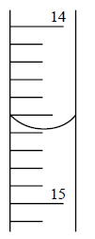  The reading shown on the burette is: | 14.59 mL
20 | The correct chemical substance used to signal the conclusion of the titration between sodium hydroxide and ethanoic acid. | phenolphthalein
21 | The colour of the final solution as per Question 20 if the ethanoic acid is in the conical flask. | Colourless/pale pink
22 | 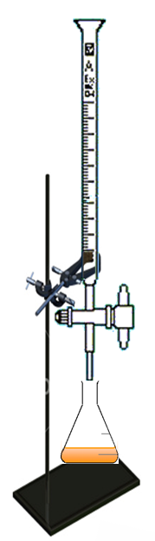  In the titration between hydrochloric acid (from the burette)  and sodium carbonate, state the name of the solution that  should be used as a final rinse for: | 1. conical flask  Distilled water
22 |  | 2. burette  Hydrochloric acid
23 | 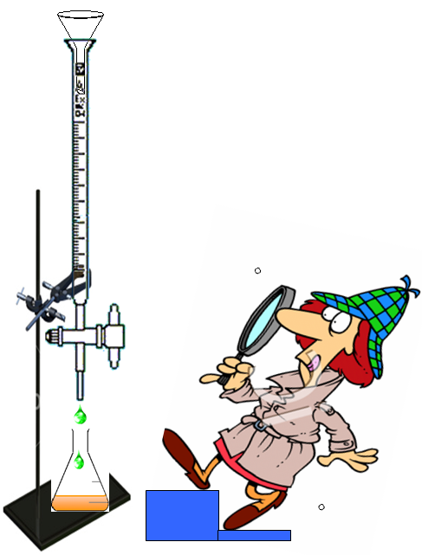  Identify two (2) possible sources of error from this titration cartoon. | 1.  Parallax error
23 |  | 2.  Funnel placement / dripping tap
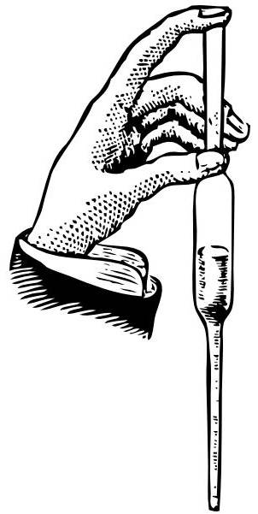
NOTE: 1) Please hand this sheet in BEFORE doing the Titration component of the Test.

- Ask your teacher to assess your pipetting skills.

1

END OF WRITTEN SECTION

